Market Monitor - Democratic Republic of the Congo - 2026-05

Highlights
Food prices in the Democratic Republic of the Congo decreased in May 2026, though significant volatility in key commodities signals a high risk of future price hikes. The national average cost of the food basket fell by 8.8% month-over-month (MoM) and 17.1% year-over-year (YoY). This decline was primarily driven by falling prices for staples like Wheat flour (↓18.7% MoM) and Beans (↓16.5% MoM). However, these decreases were offset by a hyperinflationary surge in the price of raw Maize (↑69.0% MoM) and a sharp increase in Palm Oil (↑21.1% MoM).
Key market drivers in May include:
- Widespread Deflation: Significant price drops across most staples, including wheat flour, beans, and imported rice, were the primary cause of the overall food basket's decline.
- Hyperinflation in Raw Maize: A monthly price surge of 69.0% for raw maize points to a severe supply chain disruption, suggesting maize flour prices will likely rise sharply in the near future.
- Currency Stability: The Congolese Franc (CDF) remained stable against the USD (appreciating 0.9% MoM), confirming that price volatility was driven by commodity-specific market factors rather than currency depreciation.
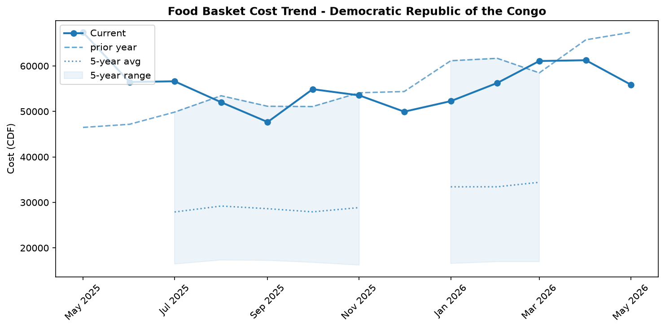
Food basket cost trend

Market Overview
The national market in the Democratic Republic of the Congo experienced a notable, yet potentially misleading, deflationary trend in May 2026. The overall cost of the food basket decreased significantly by 8.8% month-over-month and 17.1% year-over-year. This downturn was primarily driven by sharp price reductions in key staples, including Beans (-16.5%), Wheat flour (-18.7%), and imported Rice (-7.3%). A slight month-on-month appreciation of the Congolese Franc (CDF) by 0.94% against the USD likely contributed to easing the cost of these imported goods. However, this positive trend is undermined by severe underlying volatility and strong counter-inflationary pressures. A hyperinflationary surge in the price of raw Maize (+69.0%) and a substantial increase in Palm Oil (+21.1%) signal significant supply-side shocks that have not yet fully impacted retail prices. The market outlook is therefore highly precarious. The dramatic rise in raw material costs, coupled with persistent logistical challenges in eastern provinces, suggests that the current period of falling prices is temporary and a sharp upward price correction is highly probable in the near future.

Commodity Analysis
A stark divergence in price trends characterized the commodity market in May. The most significant development was a major anomaly between raw Maize and its processed form. While raw Maize prices experienced a hyperinflationary surge of 69.0% month-over-month, the price of Maize flour paradoxically decreased by 3.1%. This discrepancy indicates that millers and retailers are currently selling flour produced from older, cheaper grain stocks. A significant upward price correction for Maize flour is imminent as these higher input costs are inevitably passed on to consumers.
In contrast, several key staples drove the overall food basket cost down. Bean prices fell sharply by 16.5%, making them a primary contributor to the month's deflationary trend. Other cereals followed suit, with imported Rice and Wheat flour recording substantial decreases of 7.3% and 18.7%, respectively. The main outlier, alongside raw Maize, was Palm Oil, which saw its price climb by 21.1%. This increase runs contrary to the general market movement and points to specific supply-side pressures, likely stemming from production and transport disruptions in key sourcing areas. The overall 8.8% decrease in the food basket cost thus masks these competing and volatile price movements, with leading indicators pointing towards future inflation.
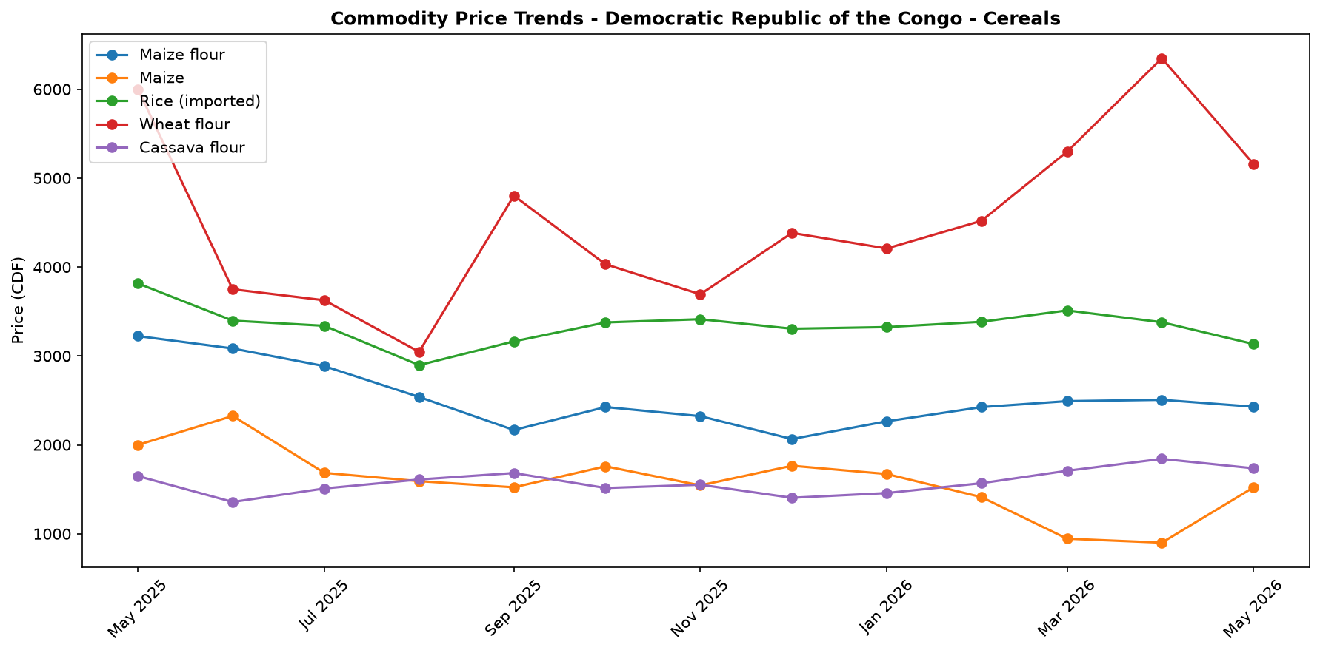
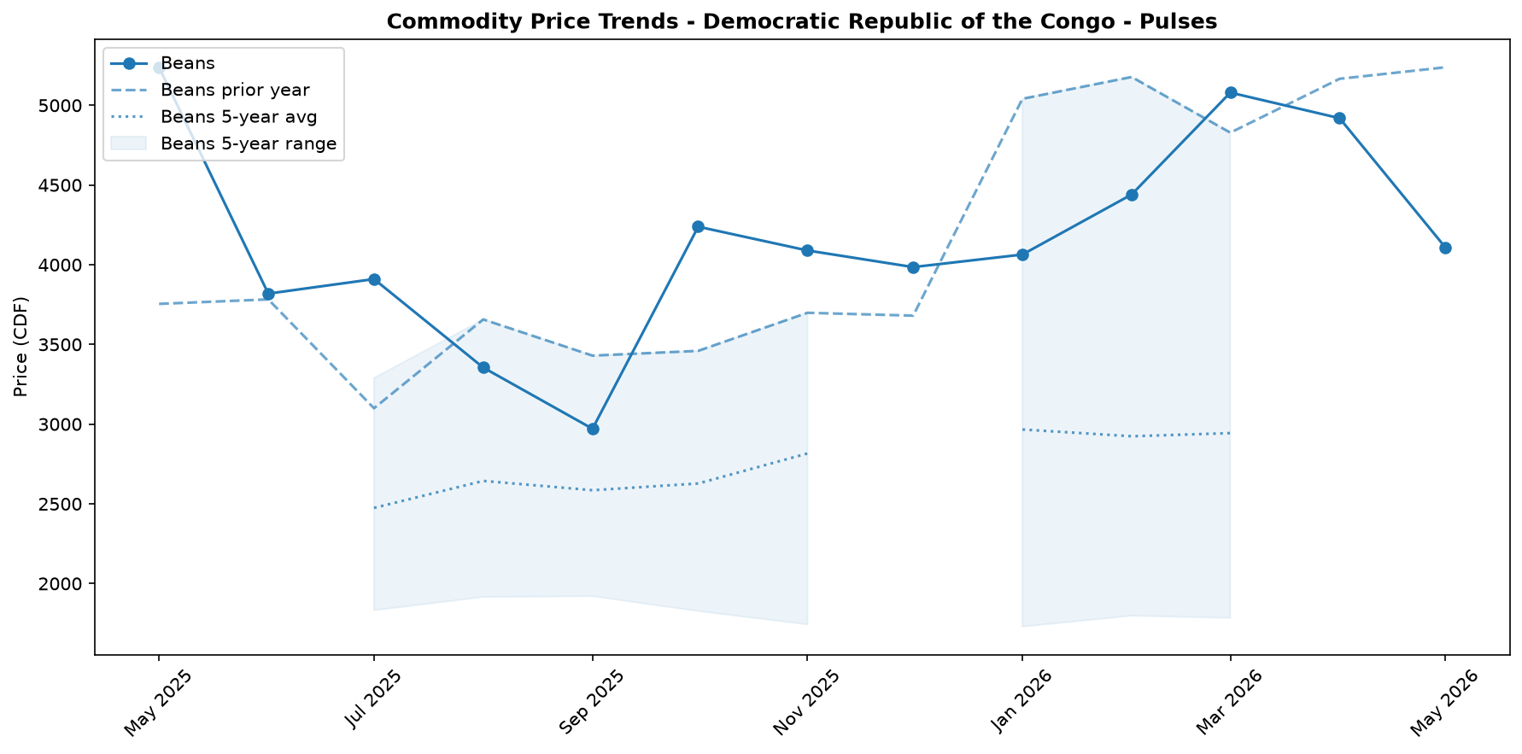
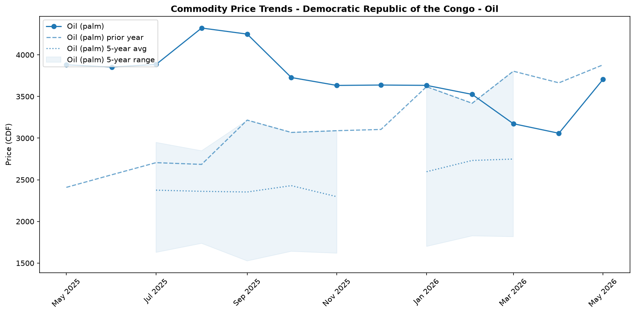
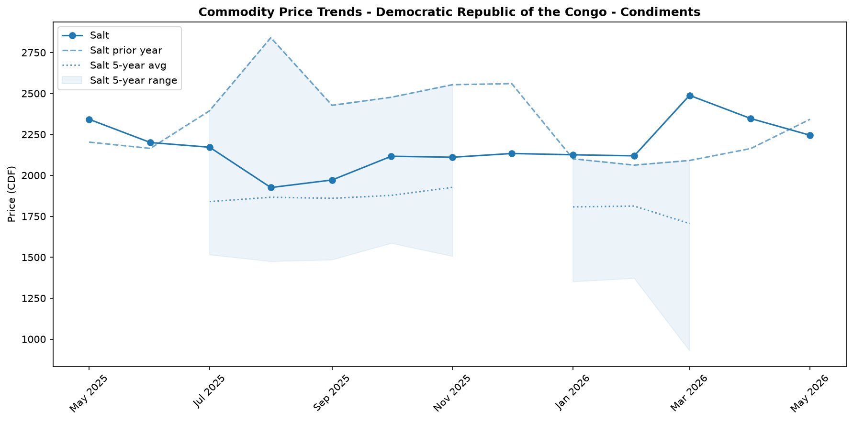

Regional Highlights
The national average price decrease conceals significant and worsening market fragmentation, particularly in the eastern provinces. While national data shows a decline, contextual reports from Ituri, North Kivu, and South Kivu indicate a deteriorating situation. The national price spikes for raw Maize (+69.0%) and Palm Oil (+21.1%) are likely early indicators of severe, localized supply chain disruptions in these regions.
These disruptions are fueled by a combination of acute insecurity and public health crises. Ongoing armed conflict and massive internal displacement are severely restricting humanitarian access and commercial transport (evt_drc_2). Compounding this, the declaration of a Public Health Emergency of International Concern due to the Bundibugyo virus disease (BVD) outbreak has led to official trade and travel restrictions, further strangling logistical corridors (evt_drc_1). While an April index suggested a fragile stability in Ituri (evt_drc_4), the combination of these recent events is expected to exert significant upward pressure on local food prices, creating a stark contrast with the current national trend.
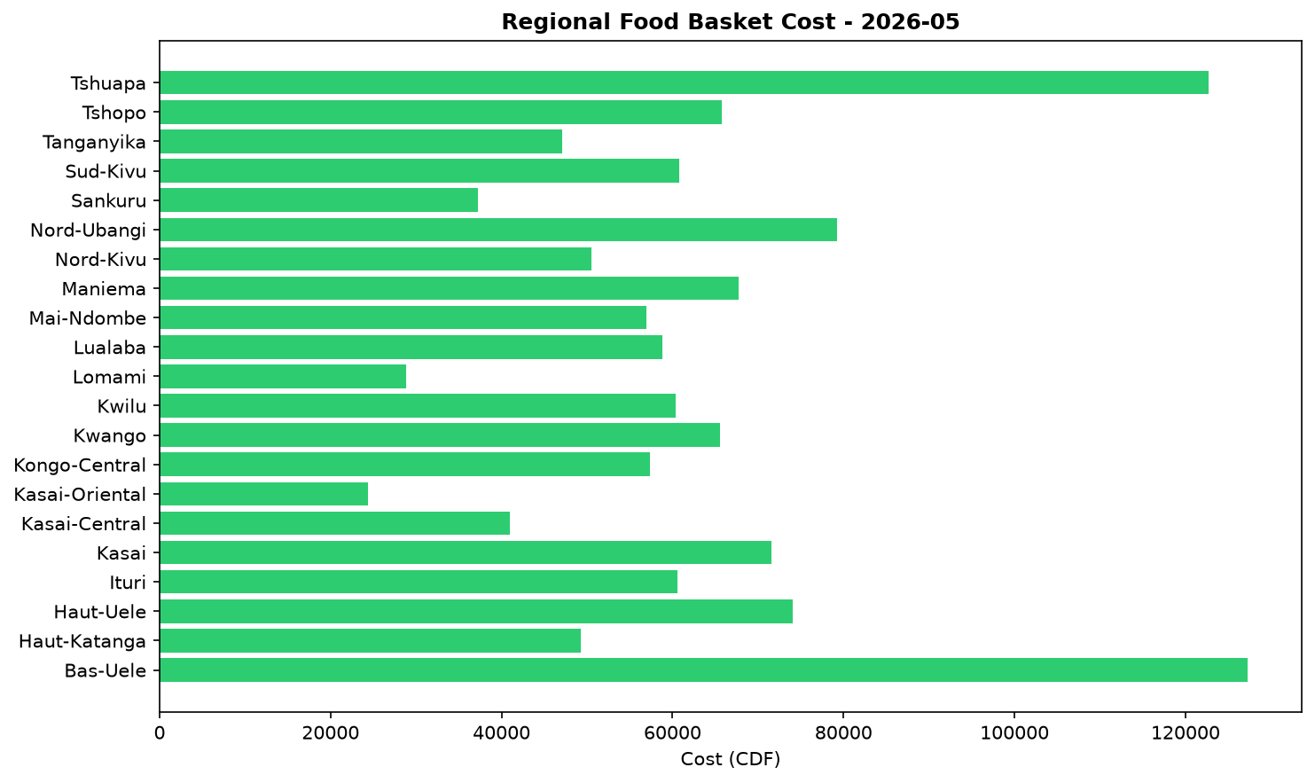

Exchange Rate Analysis
The Congolese Franc (CDF) has recently shown signs of appreciation, trading at an average of 2307.0 per USD. This represents a slight month-on-month strengthening of 0.94 percent, which could help ease the cost of imported goods. However, this short-term gain is set against a significant long-term depreciation. On a year-on-year basis, the CDF has weakened by 20.57 percent, highlighting sustained pressure on the currency over the past twelve months. This substantial annual depreciation continues to exert upward pressure on the prices of key imported commodities, including wheat, rice, cooking oil, and fuel. While the recent monthly appreciation offers a slight reprieve, the overall weaker currency remains a primary driver of food price inflation, eroding the purchasing power of vulnerable households who rely on these imported staples.

References
- [rw_4214178] ReliefWeb (2026-05-31) IOM: Multi-Country Ebola Bundibugyo Outbreak Situation Report No. 2 (22 - 27 May 2026)
https://reliefweb.int/node/4214178
- [rw_4214159] ReliefWeb (2026-05-30) The metric of life and death: How local and technical experts are strengthening mortality measurement in Eastern DRC
https://reliefweb.int/node/4214159
- [rw_4214140] ReliefWeb (2026-05-29) Disease Outbreak News: Ebola disease caused by Bundibugyo virus - Democratic Republic of the Congo & Uganda (29 May 2026)
https://reliefweb.int/node/4214140
- [rw_4214053] ReliefWeb (2026-05-29) Democratic Republic of the Congo - Ituri Province: Solutions and Mobility Index | Cross-Border Stability Assessment (April 2026)
https://reliefweb.int/node/4214053
- [rw_4214043] ReliefWeb (2026-05-29) UNFPA Flash Update - Bundibugyo Ebola Virus Disease (BVD) Outbreak (20 - 26 May 2026)
https://reliefweb.int/node/4214043
- [rw_4214032] ReliefWeb (2026-05-29) Response to Ebola Outbreak in Democratic Republic of Congo (DRC) and Uganda
https://reliefweb.int/node/4214032
- [rw_4214019] ReliefWeb (2026-05-28) DRC Logistics and Telecommunications Cluster - Standard Operating Procedures (SOPs) for Common Logistics Services, May 2026
https://reliefweb.int/node/4214019
- [rw_4214005] ReliefWeb (2026-05-28) UNICEF’s first international shipment of emergency Ebola response supplies arrives in Ituri, northeastern Democratic Republic of the Congo
https://reliefweb.int/node/4214005
- [rw_4213975] ReliefWeb (2026-05-28) Message by the WHO Director-General to the people of the Democratic Republic of the Congo
https://reliefweb.int/node/4213975
- [rw_4213814] ReliefWeb (2026-05-27) DRC: One in four confirmed Ebola deaths are children underscoring the urgent need to protect them
https://reliefweb.int/node/4213814
- [seerist_1028756] Seerist (2026-05-28) Big Picture series: Ebola outbreak prompts increased travel monitoring, targeted entry restrictions
- [seerist_1028721] Seerist (2026-05-27) Big Picture series: Carbon markets in Sub-Saharan Africa – growing opportunities amid regulatory, integrity challenges
- [seerist_1028614] Seerist (2026-05-20) US-Congo strategic partnership to advance peace deal enforcement, but challenges to critical minerals output will remain
- [seerist_1028608] Seerist (2026-05-19) Ebola outbreak highlights response weaknesses amid fragmented administrative control, funding decline
- [seerist_1028607] Seerist (2026-05-19) Big Picture series: France’s push into anglophone Africa to bring new commercial opportunities despite West African controversies
- [seerist_1028505] Seerist (2026-05-12) Insecurity in mining provinces to persist in coming years despite planned deployment of paramilitary force
- [seerist_1028483] Seerist (2026-05-11) President signalling two ways to stay in office beyond 2028 suggests renewed push to extend tenure
- [seerist_1028458] Seerist (2026-05-08) US sanctions on former president to strengthen ruling camp, raise compliance risks
- [seerist_1028377] Seerist (2026-04-30) Risk zones, risk ratings changed to reflect impact of rebel offensive
- [seerist_1028293] Seerist (2026-04-24) Fighting in eastern Congo to continue in coming months as implementation of peace process remains uneven

